**MONGODB**

**Name: DARA VAMSI Date: 13-06-2025**

**Reg No: 22BCB7293**

**Gmail: vamsi.22bcb7293@vitapstudent.ac.in**

**SHARDING**

**C:\Program Files\MongoDB\Server\8.0\bin**

**Open PowerShell -> Run as Administrator**

Config Server

mkdir C:\data\cfg1, C:\data\cfg2, C:\data\cfg3

Shard Servers (2 shards, 3 nodes each)

mkdir C:\data\shard1_1, C:\data\shard1_2, C:\data\shard1_3

mkdir C:\data\shard2_1, C:\data\shard2_2, C:\data\shard2_3

Mongos router

mkdir C:\data\mongos

**Open 3 Powershells:**

mongod --configsvr --replSet configReplSet --port 27019 --dbpath C:\data\cfg1 --bind_ip localhost

mongod --configsvr --replSet configReplSet --port 27020 --dbpath C:\data\cfg2 --bind_ip localhost

mongod --configsvr --replSet configReplSet --port 27021 --dbpath C:\data\cfg3 --bind_ip localhost

mongosh --port 27019

rs.initiate({

_id: "configReplSet",

configsvr: true,

members: [

{ _id: 0, host: "localhost:27019" },

{ _id: 1, host: "localhost:27020" },

{ _id: 2, host: "localhost:27021" }

]

})

rs.status()

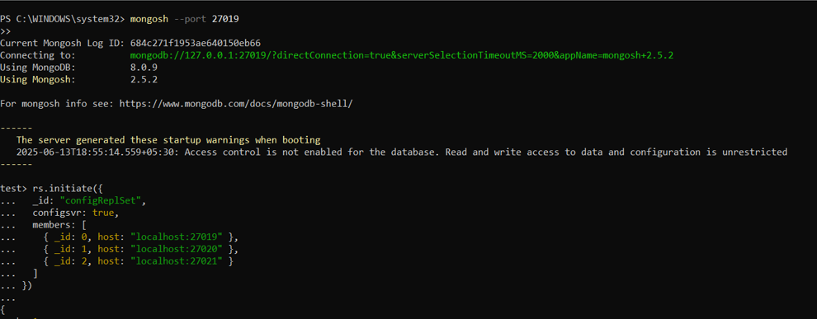

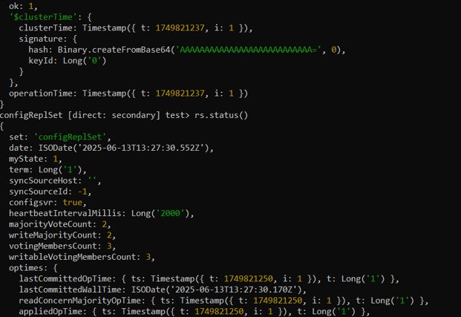

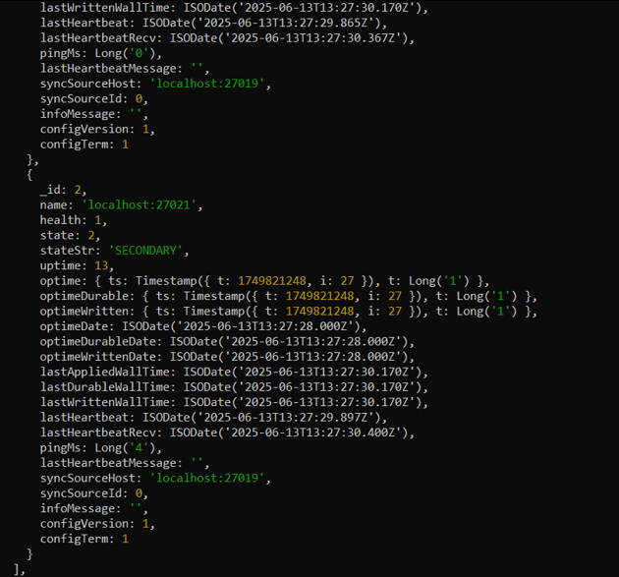

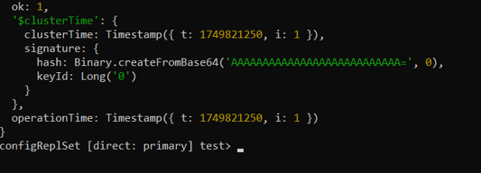

open 3 new PowerShell windows and run

mongod --shardsvr --replSet shard1ReplSet --port 27022 --dbpath C:\data\shard1_1 --bind_ip localhost

mongod --shardsvr --replSet shard1ReplSet --port 27023 --dbpath C:\data\shard1_2 --bind_ip localhost

mongod --shardsvr --replSet shard1ReplSet --port 27024 --dbpath C:\data\shard1_3 --bind_ip localhost

mongosh --port 27022

rs.initiate({

_id: "shard1ReplSet",

members: [

{ _id: 0, host: "localhost:27022" },

{ _id: 1, host: "localhost:27023" },

{ _id: 2, host: "localhost:27024" }

]

})

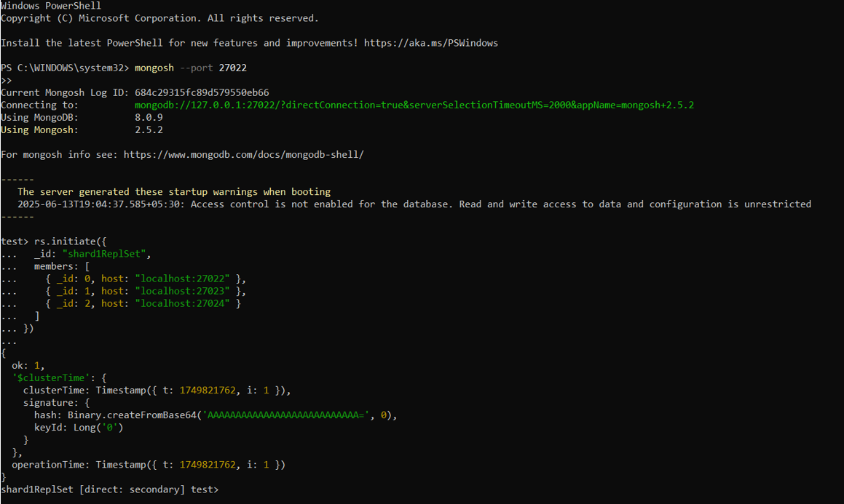

**Shard 2**

Open 3 new PowerShell windows and run

mongod --shardsvr --replSet shard2ReplSet --port 27025 --dbpath C:\data\shard2_1 --bind_ip localhost

mongod --shardsvr --replSet shard2ReplSet --port 27026 --dbpath C:\data\shard2_2 --bind_ip localhost

mongod --shardsvr --replSet shard2ReplSet --port 27027 --dbpath C:\data\shard2_3 --bind_ip localhost

mongosh --port 27025

rs.initiate({

_id: "shard2ReplSet",

members: [

{ _id: 0, host: "localhost:27025" },

{ _id: 1, host: "localhost:27026" },

{ _id: 2, host: "localhost:27027" }

]

})

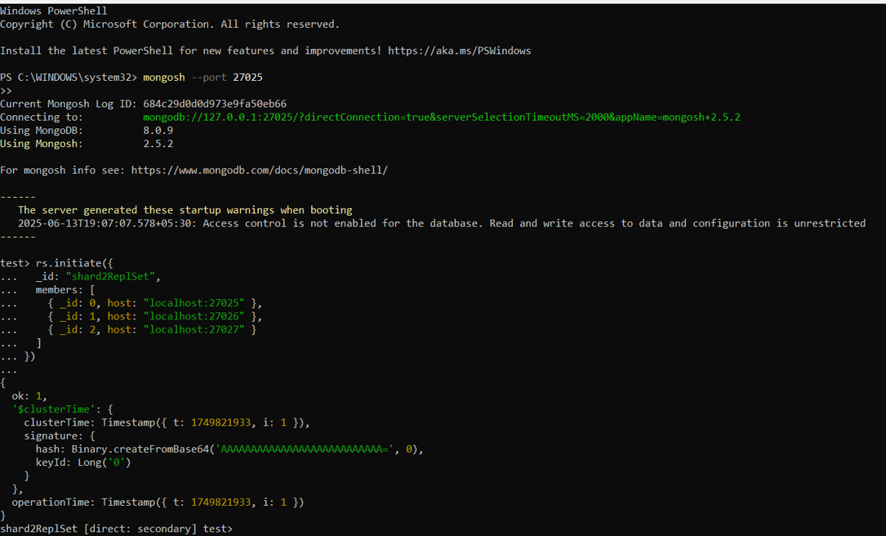

**Open New Power shell**

mongos --configdb configReplSet/localhost:27019,localhost:27020,localhost:27021 --port 27018 --bind_ip localhost

mongosh --port 27018

sh.addShard("shard1ReplSet/localhost:27022,localhost:27023,localhost:27024")

sh.addShard("shard2ReplSet/localhost:27025,localhost:27026,localhost:27027")

sh.status()

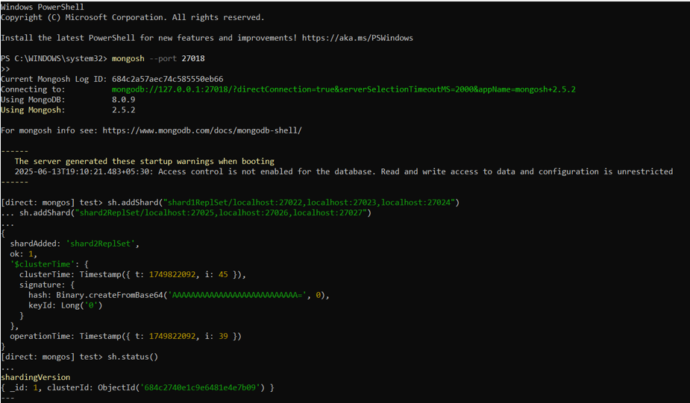

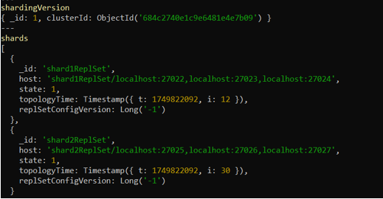

sh.enableSharding("testDB")

sh.shardCollection("testDB.testCollection", { "_id": "hashed" })

for (let i = 0; i < 1000; i++) {

db.testCollection.insert({

userId: i,

text: "hello " + i,

time: new Date()

})

}

db.testCollection.getShardDistribution()

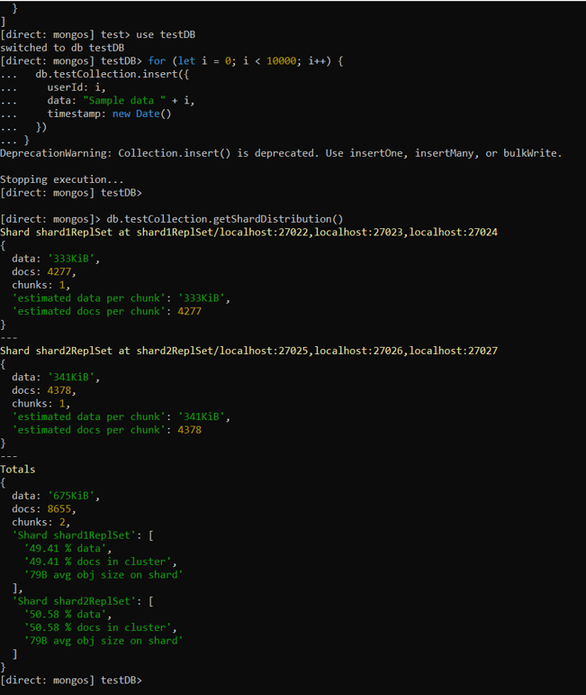

**MongoDB Compass:**

